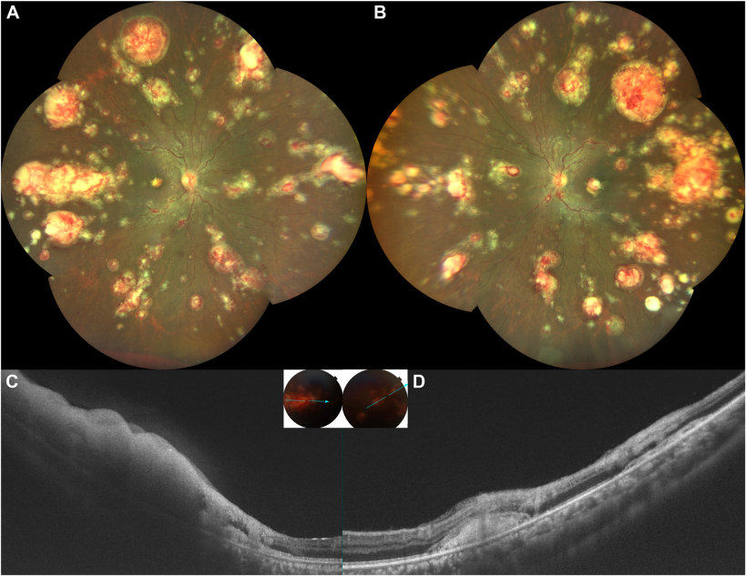

A 28-year-old Indian woman on oral Imatinib 400 mg once a day, presented withcomplaints of decreased vision in both eyes for 1 week. Her visual acuity was 20/160 in both eyes. A-B, Retinal evaluation revealedbilateral tortuous, dilated retinal veins, and multifocal, symmetrical, retinal infiltrates ranging from 1 to 8-disc diameters. C, Swept sourceOCT passing through the lesions showed full-thickness homogenous hyperreflectivity of the retina, subretinal hyperreflectivity withthickened external limiting membrane, and inner retinal hyperreflectivity (D). Based on the provided images and clinical description please make an ophthalmic diagnosis for this patient. And output the diagnostic conclusions only.

**Imatinib-induced retinal toxicity.**